Code No.: | HTU/P21 | Date Established | 28/03/2019
Responsible  Department | Head of Centre and Senior Management | Date Posted | 28/03/2019
Responsible Executive | Programme Leaders/Deans  Student Deanship | Date Last Revised  Revision # 4 | 27/11/2023
Quality Nominee | Rumiana Bahova Nuseibeh | Forward Revision Date | 17/11/2024

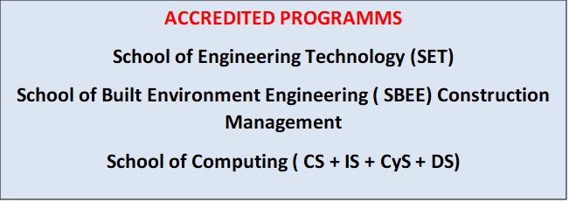

This Document was last revised : 17th November 2023

Safeguarding Learners Policy

Introduction

This policy has been developed by : Al-Hussein Technical University (HTU)

Key objectives:

Our primary consideration is to ensure that no learner is at risk of abuse or is harmed.

Our key objectives are:

● Do all that we can to ensure that learners are not at risk of abuse at HTU .

● Do all that we can to ensure that all learners are free from any kind of harassment while within HTU or while receiving a service from us; whether the harassment is from employees, peers or contractors.

● Recognize and take appropriate action, when a vulnerable young person or adult might have been abused, including in the community or family.

To meet our objectives, we commit to:

● Comply with all relevant local laws and regulations

● Set overarching principles to help our employees think about our safeguarding / child protection responsibilities , and to set a series of guidelines and procedures for learners and staff

Responsibilities:

Senior Management carries overall responsibility of implementing this policy.
The Head of Centre, ensures that this policy is kept up to date, disseminated among relevant faculty , staff and learners and procedures are followed to safeguard learners.
All Centre Staff : are responsible for abiding by the policy and for reporting concerns to the head of the Centre /HTU

● Deﬁne procedures and provide guidance on the safeguarding/child protection standards we expect and the actions our people should take to avoid risk and to respond to cases of abuse

● Communicate our Policy and guidelines to our employees, and others interested in our approach including through publishing our policy,

Our Safeguarding/protection learners’ principles

● Best interests of the learner are paramount and shall be the primary consideration in our decision making.

● We are learner centered and have adopted a rights-based approach. This helps us keep the rights of students, and vulnerable adults to care, nurturing and equality of protection sharply in focus in all our activities

● Equality of protection to ensure that students have the same positive opportunity and to engage in our activities safely regardless of their gender, ability, race, sexuality, ethnicity, religion, circumstances or age.

● Vulnerable adults require attention to optimize their safety needs and promote their access to important opportunities.

● We take responsibility to meet our obligations regarding our duty of care to all our students. This means ensuring that learners are safe and protected across all our activities and facilities.

● We reject the use of child or forced labor in our educational activities and in our business relationships.

● We make clear our standards to contractors and suppliers (industries) and audit those we identify as being high risk.

● We recognize and acknowledge an element of risk can exist in many learning situations, and while we may never be able to eliminate this completely, we will do all we can to reduce or limit its impact.

● We are honest and transparent in our approach and publicly disclose both this policy and the way we work to try and protect all our students.

● In general, excepting where there is an apparent immediate threat to life , all personally identiﬁable information concerning students should only be shared with the appropriate official authorities.

● We support those working within HTU to recognize and respond to student concerns, related to risk and abuse issues.

● We have a dedicated team of educators in place to take responsibility for the protection of vulnerable adults with a code of conduct for safeguarding learners.

This policy may be read in conjunction with the Learner Support Policy (P12)

End of Policy.

